IALD Presents Merit Award for the Semiramis Hotel
Focus Lighting Accepts Award
New York, NY, April 13, 2005 – At its 22nd Annual IALD Awards Presentation, the International Association of Lighting Designers (IALD) is pleased to present an Award of Merit for Semiramis Hotel, a modern boutique hotel located in Athens, Greece. The entry was judged in the hospitality category. This year, 15 projects earned awards of merit, and two were in the hospitality category. Principal lighting designer on the project is Paul Gregory, principal of Focus Lighting in New York, New York. Other lighting designers credited on the project include Michael Cummings, Christine Caracciolo, Jennifer Alexander and JP Lira.
click on thumbnails
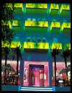 | 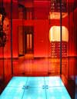 | 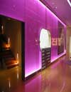 | 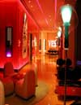 | 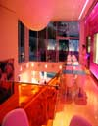
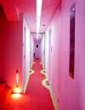 | 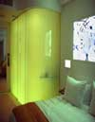 |  | 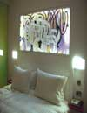 | 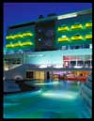
The design challenge was to illuminate the highly reflective glass and tile light fixtures embedded within the architecture to accent the distinctive materials. At the hotel’s entrance, horizontal LED strips light up each stair. Above, shadows are cast on the green glass balconies against the blue walls creating a colorful façade. In the lobby, color changing LED strips between a pink glass wall create a dramatic, evolving environment. In the guest rooms, translucent glass enclosed bathrooms glow from partially recessed downlights. A unique acrylic backlit headboard and custom recessed adjustable bedside wall sconces provide innovative room lighting. One judge summed up the design as “over the top, edgy and dynamic.”
At this year’s 22nd annual event, the IALD awarded 23 projects that represented six of the seven categories. Fifteen projects earned IALD Awards of Merit, two in both the hospitality and corporate categories, three in the site/façade category, and four in each the retail/entertainment and monumental structures/public spaces categories. Seven IALD Awards of Excellence were also awarded: one in both the corporate and retail categories; two in site/façade; and three in the category of monumental structures/public spaces. The highest point earner wins the Radiance Award for Excellence in Architectural Lighting Design. An IALD Special Citation for innovative use of materials and techniques for daylighting control was granted for an entry in the academic/institutional category.
The IALD Lighting Design Awards program, established in 1983 and co-sponsored by Professional Lighting Design magazine, honors lighting projects that display high aesthetic achievement backed by technical expertise. Entries are submitted into one of seven categories: Academic/Institutional; Corporate; Hospitality; Monumental Structures/Public Spaces; Residential; Retail/Entertainment; and Site/Façade. Additionally, projects can also be submitted for consideration in the sustainable design award category, which means the project undergoes an additional round of judging keyed solely to the fulfillment of sustainable design principles. A panel of award-winning lighting designers and architects review the projects.
This year, the IALD received 141 submissions from 14 countries. The IALD, established in 1969, is an international organization dedicated to the profession of architectural lighting design. Based in Chicago and comprised of 700 members throughout North and South America, Europe, Asia and Australia, the IALD’s role is to set the global standard for lighting design excellence.
Additional information can be downloaded from www.IALD.org.

